ASSESMENT TOOL-2 (Application based Question)

Course Code: DSA0504 Course Title: Query Processing

CO Assessed: CO1 Assessment: Application Based
Question

Weightage: Total Marks:

Student Name: Edrin J S Register No:192524041

Faculty In charge: Dr. Mahesh Project Mode:Individual Submition
Muthulakshmi

Code of Conduct:
I, Edrin J S (192524041) hereby certify that this assessment submission is my original work. I confirm that I have completed this work independently and have adhered to all the guidelines and academic integrity policies prescribed by the institution. I understand that any form of plagiarism, copying, fabrication, or other academic misconduct may result in disciplinary action as per the rules and regulations of the institution.
Signature:edrinjs

Question 1: Student Admission Data Cleaning
Aim:
To write a Python program to read a CSV file containing student admission records collected from multiple departments, clean and standardize the data by removing duplicate records, correcting inconsistent department name capitalization, trimming extra spaces from student names, and handling missing phone numbers, and to save the cleaned dataset into a new CSV file.
Approach:
- Create/read the raw CSV file using pandas.read_csv().
- Strip extra whitespace from student names using str.strip().
- Standardize department names to title case (e.g. 'MECHANICAL' -> 'Mechanical').
- Replace missing phone numbers with a placeholder value ('Not Provided').
- Remove duplicate records based on StudentID using drop_duplicates().
- Reset the index and export the cleaned data to a new CSV file.
Program:
import pandas as pd

# Step 1: Create a sample raw CSV file (simulating data received from multiple departments)
raw_data = {
'StudentID': [101, 102, 103, 104, 102, 105, 106, 103],
'StudentName': ['Aarav Sharma ', ' Priya Nair', 'Rohan Gupta', 'Sneha Reddy ',
' Priya Nair', 'Kabir Singh', ' Ananya Iyer', 'Rohan Gupta'],
'Department': ['computer science', 'MECHANICAL', 'Electronics ', 'civil engineering',
'MECHANICAL', 'Computer Science', ' electronics', 'Electronics '],
'Phone': ['9876543210', '', '9123456780', '9988776655',
'', '9012345678', None, '9123456780']
}

df = pd.DataFrame(raw_data)
df.to_csv('admissions_raw.csv', index=False)

print("----- RAW DATA -----")
print(df)

# Step 2: Read the CSV file
df = pd.read_csv('admissions_raw.csv', dtype={'Phone': str})

# Step 3: Clean and standardize student names (strip extra spaces)
df['StudentName'] = df['StudentName'].str.strip()

# Step 4: Standardize department names (title case + strip spaces)
df['Department'] = df['Department'].str.strip().str.title()

# Step 5: Handle missing phone numbers
df['Phone'] = df['Phone'].fillna('Not Provided')
df['Phone'] = df['Phone'].replace('', 'Not Provided')

# Step 6: Remove duplicate records based on StudentID
df = df.drop_duplicates(subset='StudentID', keep='first')

# Step 7: Reset index and save cleaned data
df = df.reset_index(drop=True)
df.to_csv('admissions_cleaned.csv', index=False)

print("\n----- CLEANED DATA -----")
print(df)
print(f"\nTotal records after cleaning: {len(df)}")

Output:
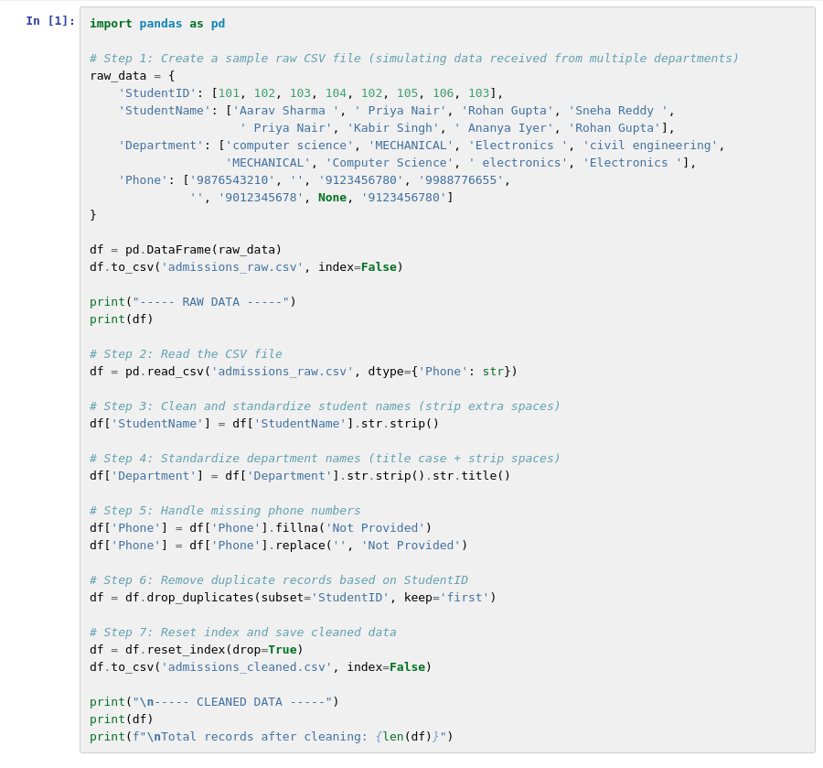
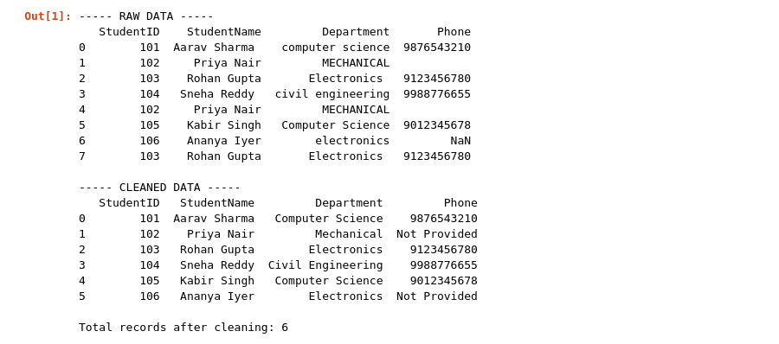

Result:
The Python program was executed successfully. The raw dataset of 8 records containing duplicate entries, inconsistent department names and missing phone numbers was cleaned and standardized. Duplicate StudentIDs were removed, department names were converted to title case, names were trimmed of extra spaces, and missing phone numbers were marked as 'Not Provided', producing 6 validated records which were saved to admissions_cleaned.csv.

Question 2: Employee Data Integration
Aim:
To write a Python program to read employee details from a CSV file and department details from a JSON file, combine the employee and department information using the common Department ID field, identify records with missing department details, and generate a consolidated dataset suitable for storage in a relational database.
Approach:
- Read the employee CSV file using pandas.read_csv().
- Load the department JSON file using Python's json module and convert it into a DataFrame.
- Merge the employee data with the department data on DepartmentID using a left join (pd.merge).
- A left join keeps every employee record, even where DepartmentID has no match in the JSON file, so those rows appear with a null DepartmentName.
- Identify and list the records with missing department details.
- Export the consolidated DataFrame to a CSV file, ready for loading into a relational database table.
Program:
import pandas as pd
import json

# Step 1: Sample employee CSV data
employees = pd.DataFrame({
'EmployeeID': [1, 2, 3, 4],
'EmployeeName': ['Anil Mehta', 'Sonal Kapoor', 'Rahul Jain', 'Divya Menon'],
'DepartmentID': ['D01', 'D02', 'D05', 'D03']
})
employees.to_csv('employees.csv', index=False)

# Step 2: Sample department JSON data
departments = [
{"DepartmentID": "D01", "DepartmentName": "Finance"},
{"DepartmentID": "D02", "DepartmentName": "Human Resources"},
{"DepartmentID": "D03", "DepartmentName": "Marketing"}
]
with open('departments.json', 'w') as f:
json.dump(departments, f)

# Step 3: Read both files
emp_df = pd.read_csv('employees.csv')
with open('departments.json') as f:
dept_data = json.load(f)
dept_df = pd.DataFrame(dept_data)

# Step 4: Merge on DepartmentID (left join keeps all employees)
merged_df = pd.merge(emp_df, dept_df, on='DepartmentID', how='left')

# Step 5: Identify employees with missing department details
missing_dept = merged_df[merged_df['DepartmentName'].isna()]

# Step 6: Save the consolidated dataset (ready for a relational database)
merged_df.to_csv('employee_department_consolidated.csv', index=False)

print("Consolidated Employee-Department Data:")
print(merged_df)
print("\nRecords with missing department details:")
print(missing_dept)

Output:
Consolidated Employee-Department Data:
EmployeeID EmployeeName DepartmentID DepartmentName
0 1 Anil Mehta D01 Finance
1 2 Sonal Kapoor D02 Human Resources
2 3 Rahul Jain D05 NaN
3 4 Divya Menon D03 Marketing

Records with missing department details:
EmployeeID EmployeeName DepartmentID DepartmentName
2 3 Rahul Jain D05 NaN
Result:
The Python program was executed successfully. The employee and department datasets were merged using DepartmentID. Employee 'Rahul Jain' (DepartmentID D05) was identified as having no matching department record, and the consolidated dataset was saved to employee_department_consolidated.csv for further use in the relational database.

Question 3: Hospital Patient Data Validation
Aim:
To write a Python program to read patient information from a CSV file containing patient IDs, names, ages, blood groups and contact numbers, identify and correct data quality issues such as invalid ages, missing values and duplicate patient IDs, and generate a validated dataset ready for import into the hospital database.
Approach:
- Read the patient CSV file, keeping ContactNumber as a string to avoid unwanted numeric conversion.
- Remove duplicate records based on PatientID using drop_duplicates().
- Detect invalid ages (negative values or values above 120) and missing ages.
- Replace invalid or missing ages with the median of the valid ages.
- Replace missing contact numbers with 'Not Available'.
- Reset the index and export the validated dataset to a new CSV file.
Program:
import pandas as pd
import numpy as np

# Step 1: Create a sample raw CSV file (simulating hospital patient records)
raw_data = {
'PatientID': ['P001', 'P002', 'P003', 'P004', 'P002', 'P005', 'P006'],
'Name': ['Ravi Kumar', 'Meena Das', 'Arjun Verma', 'Divya Nair', 'Meena Das', 'Farhan Ali', 'Kiran Rao'],
'Age': [34, -5, 45, 150, -5, 29, np.nan],
'BloodGroup': ['B+', 'O+', 'A-', 'AB+', 'O+', 'B-', 'O+'],
'ContactNumber': ['9876501234', '9876502345', None, '9876504567', '9876502345', '9876506789', '9876507890']
}

df = pd.DataFrame(raw_data)
df.to_csv('patients_raw.csv', index=False)

print("----- RAW PATIENT DATA -----")
print(df)

# Step 2: Read the dataset
df = pd.read_csv('patients_raw.csv', dtype={'ContactNumber': str})

# Step 3: Remove duplicate PatientIDs
df = df.drop_duplicates(subset='PatientID', keep='first')

# Step 4: Fix invalid ages (negative or unrealistic values replaced with median age)
valid_ages = df.loc[(df['Age'] > 0) & (df['Age'] < 120), 'Age']
median_age = valid_ages.median()
df['Age'] = df['Age'].apply(lambda x: median_age if pd.isna(x) or x <= 0 or x >= 120 else x)

# Step 5: Handle missing contact numbers
df['ContactNumber'] = df['ContactNumber'].fillna('Not Available')

# Step 6: Reset index and export the validated dataset
df = df.reset_index(drop=True)
df.to_csv('patients_validated.csv', index=False)

print("\n----- VALIDATED PATIENT DATA -----")
print(df)
print(f"\nTotal valid records: {len(df)}")

Output:
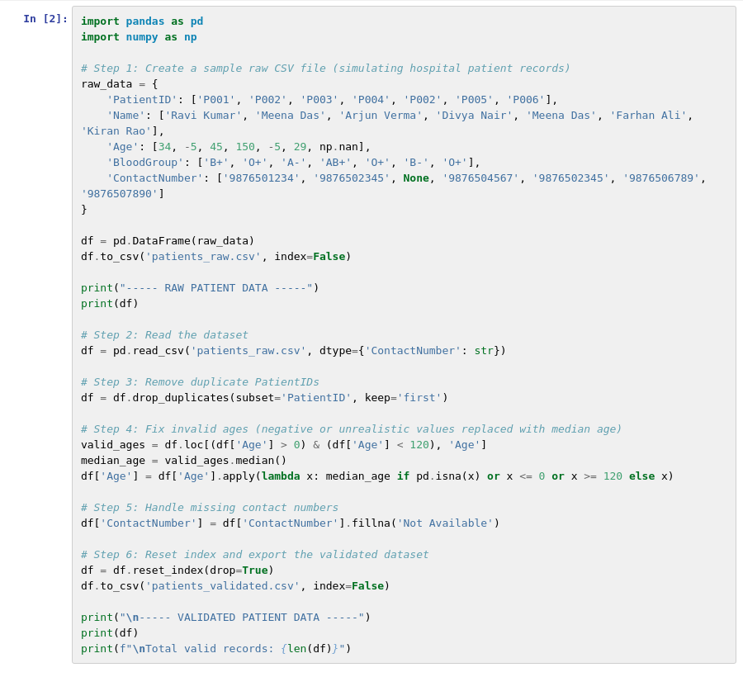
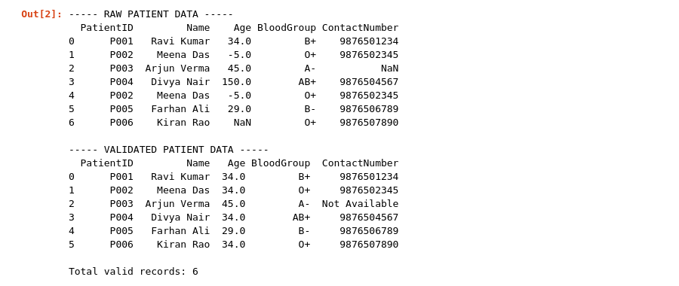

Result:
The Python program was executed successfully. The raw data contained a duplicate PatientID, a negative age, an unrealistic age, a missing age, and a missing contact number. These issues were corrected - the duplicate record was removed, invalid/missing ages were replaced with the median valid age (34), and the missing contact number was marked as 'Not Available' - producing 6 validated patient records saved to patients_validated.csv.

Question 4: Library Database Preparation
Aim:
To write a Python program to read book details received in JSON format from different publishers, validate the required fields, detect missing or inconsistent information, remove duplicate records, and produce a cleaned dataset ready for insertion into the library database.
Approach:
- Load the JSON file using Python's json module and convert it into a pandas DataFrame.
- Remove duplicate records based on BookID using drop_duplicates().
- Validate that the required fields (Title, Author, Year) are present and non-empty for every record.
- Separate valid records from incomplete records based on the validation result.
- Export the cleaned dataset to a CSV file, ready for insertion into the library database.
Program:
import pandas as pd
import json

# Step 1: Sample raw book data received from publishers (JSON format)
books = [
{"BookID": "B001", "Title": "Data Science Basics", "Author": "R. Sharma", "Publisher": "TechPress", "Year": 2021},
{"BookID": "B002", "Title": "Python for Everyone", "Author": "", "Publisher": "CodeWorks", "Year": 2019},
{"BookID": "B003", "Title": "Advanced Databases", "Author": "N. Iyer", "Publisher": "TechPress", "Year": None},
{"BookID": "B001", "Title": "Data Science Basics", "Author": "R. Sharma", "Publisher": "TechPress", "Year": 2021},
{"BookID": "B004", "Title": "", "Author": "S. Rao", "Publisher": "EduBooks", "Year": 2020}
]
with open('books_raw.json', 'w') as f:
json.dump(books, f)

# Step 2: Read the JSON file
with open('books_raw.json') as f:
data = json.load(f)
df = pd.DataFrame(data)

# Step 3: Remove duplicate BookIDs
df = df.drop_duplicates(subset='BookID', keep='first')

# Step 4: Validate required fields (Title, Author, Year must not be empty)
required_fields = ['Title', 'Author', 'Year']
df['IsValid'] = True
for field in required_fields:
df['IsValid'] &= df[field].notna() & (df[field].astype(str).str.strip() != '')

# Step 5: Separate clean records from incomplete ones
clean_df = df[df['IsValid']].drop(columns='IsValid').reset_index(drop=True)
incomplete_df = df[~df['IsValid']].drop(columns='IsValid').reset_index(drop=True)

# Step 6: Export the cleaned dataset ready for database insertion
clean_df.to_csv('books_cleaned.csv', index=False)
incomplete_df.to_csv('books_incomplete.csv', index=False)

print("Cleaned Book Records:")
print(clean_df)
print("\nIncomplete Records (missing required fields):")
print(incomplete_df)

Output:
Cleaned Book Records:
BookID Title Author Publisher Year
0 B001 Data Science Basics R. Sharma TechPress 2021.0

Incomplete Records (missing required fields):
BookID Title Author Publisher Year
0 B002 Python for Everyone CodeWorks 2019.0
1 B003 Advanced Databases N. Iyer TechPress NaN
2 B004 S. Rao EduBooks 2020.0
Result:
The Python program was executed successfully. Out of 5 raw book records, 1 duplicate record was removed, and among the 4 remaining unique records, 3 were found incomplete (missing author, year or title) and separated out. The single fully valid record was saved to books_cleaned.csv, ready for insertion into the library database.

Question 5: Banking Transaction Analysis
Aim:
To write a Python program to import daily transaction details received from different bank branches in CSV format, clean and standardize the records, identify invalid transactions, and save the processed data into new files for further financial analysis.
Approach:
- Import the CSV file, keeping AccountNumber as a string field.
- Remove duplicate records based on TransactionID using drop_duplicates().
- Standardize the TransactionType column to a consistent title case (e.g. 'WITHDRAWAL' -> 'Withdrawal').
- Flag a transaction as invalid if it has a blank account number or a non-positive amount.
- Split the records into valid and invalid transactions and save each to a separate CSV file.
Program:
import pandas as pd

# Step 1: Create a sample raw CSV file (simulating daily transactions from branches)
raw_data = {
'TransactionID': ['T1001', 'T1002', 'T1003', 'T1004', 'T1002', 'T1005', 'T1006'],
'AccountNumber': ['AC2001', '', 'AC2003', 'AC2004', '', 'AC2006', 'AC2007'],
'TransactionType': ['deposit', 'WITHDRAWAL', 'Deposit ', 'transfer', 'WITHDRAWAL', 'Deposit', 'withdrawal'],
'Amount': [5000, 1500, 2000, 7000, 1500, -300, 4200]
}

df = pd.DataFrame(raw_data)
df.to_csv('transactions_raw.csv', index=False)

print("----- RAW TRANSACTION DATA -----")
print(df)

# Step 2: Import the CSV file
df = pd.read_csv('transactions_raw.csv', dtype={'AccountNumber': str})

# Step 3: Remove duplicate transaction IDs
df = df.drop_duplicates(subset='TransactionID', keep='first')

# Step 4: Standardize transaction type (strip spaces, title case)
df['TransactionType'] = df['TransactionType'].str.strip().str.title()

# Step 5: Flag invalid transactions (blank account number OR negative amount)
df['IsValid'] = ~(df['AccountNumber'].isin(['', None]) | df['Amount'].le(0))

# Step 6: Separate valid and invalid transactions
valid_df = df[df['IsValid']].drop(columns='IsValid').reset_index(drop=True)
invalid_df = df[~df['IsValid']].drop(columns='IsValid').reset_index(drop=True)

# Step 7: Save processed data for further financial analysis
valid_df.to_csv('transactions_processed.csv', index=False)
invalid_df.to_csv('transactions_invalid.csv', index=False)

print("\n----- VALID TRANSACTIONS (PROCESSED) -----")
print(valid_df)

print("\n----- INVALID TRANSACTIONS -----")
print(invalid_df)

Output:
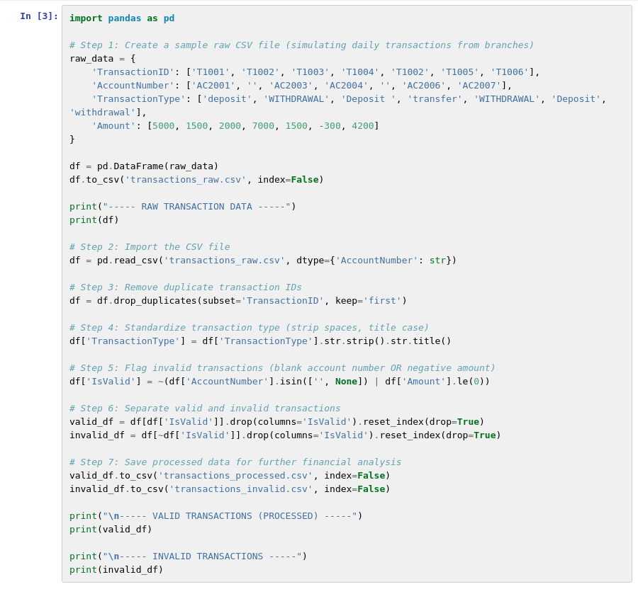

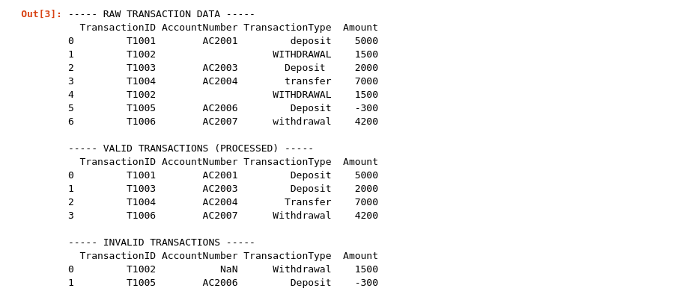
Result:
The Python program was executed successfully. The raw data contained a duplicate transaction, a transaction with a blank account number, and a transaction with a negative amount. After processing, the duplicate was removed and transaction types were standardized. 4 valid transactions were saved to transactions_processed.csv, and 2 invalid transactions were saved separately to transactions_invalid.csv for further investigation.

